|  |  |  |
| --- | --- | --- |
| Criteria | | |
| Code commits (GitHub) | Grade | D |
|  | Justification | * 20 unique-day commits |
| Weekly progress | Grade | D |
|  | Justification | * Changelog was updated weekly with details of how many hours we spent on each task and what task we have done |
| Code quality | Grade | D |
|  | Justification | * Every major method/function has proper commenting * Each method/function has its own explanation * Indentation is present |
| Legal | Grade | D |
|  | Justification | * License.txt is added in GitHub * All materials used have legal rights for commercial use * All attributions include hyperlinks to source pages |
| Value | Grade | C |
|  | Justification | The app is engaging for at least 2 hours |
| Advanced features | Grade | D |
|  | Justification | * At least 3 advanced code concepts that we haven’t learned before |
| Data Handling | Grade | C |
|  | Justification | All app constants in local text files |
| Layout | Grade | C |
|  | Justification | App works on portrait phone mode |
| Bugs | Grade | P |
|  | Justification | * Code is handled well by try/catch wherever it is neccessary |
| Readme.txt | Grade | HD |
|  |  | * App name, tittle, platform, link to github, and overview of the app * Major functions explained * API reference of major classes |
| Publishing | Grade | D |
|  |  | * Meet Google Play guidelines * App has icon, splashscreen * App has directory on GitHub with all information required to published |
| Demonstration Video | Grade | C |
|  |  | * Video is still and clear, audio is clear and easy to understand. |

# Evidences

## Code Commits

This is a link to the Changelog.md in the GitHub where the commitments are stored.

<https://github.com/TAMMYLE/WordAddicts.git/CHANGELOG.md>

## Weekly Progress

Weekly progress is updated in the changelog in GitHub.

<https://github.com/TAMMYLE/WordAddicts.git/CHANGELOG.md>

## Code Quality

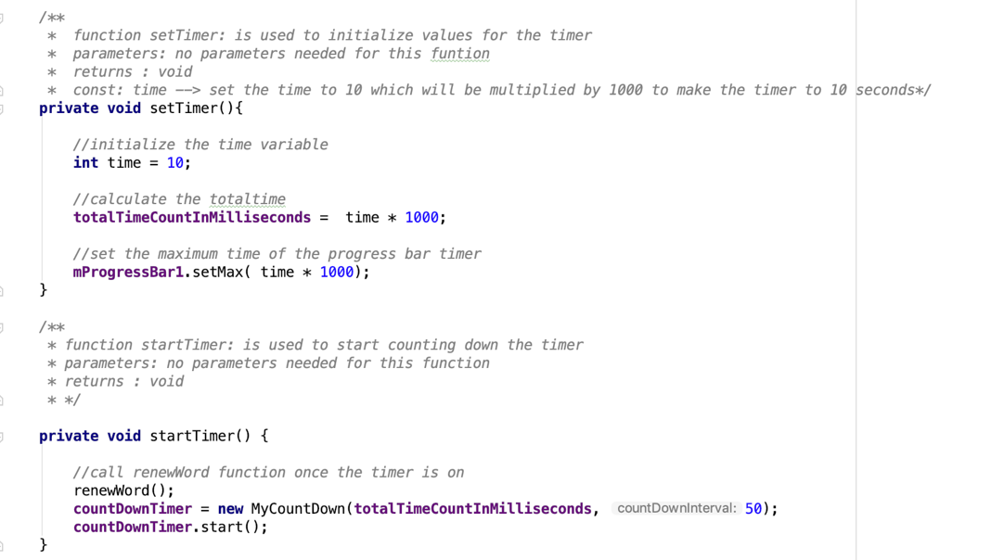

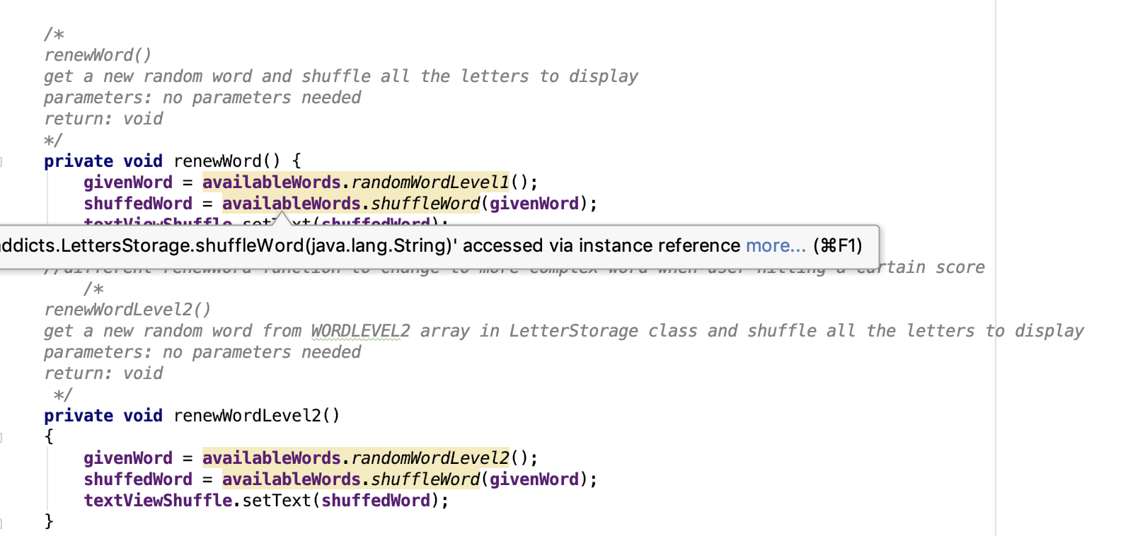

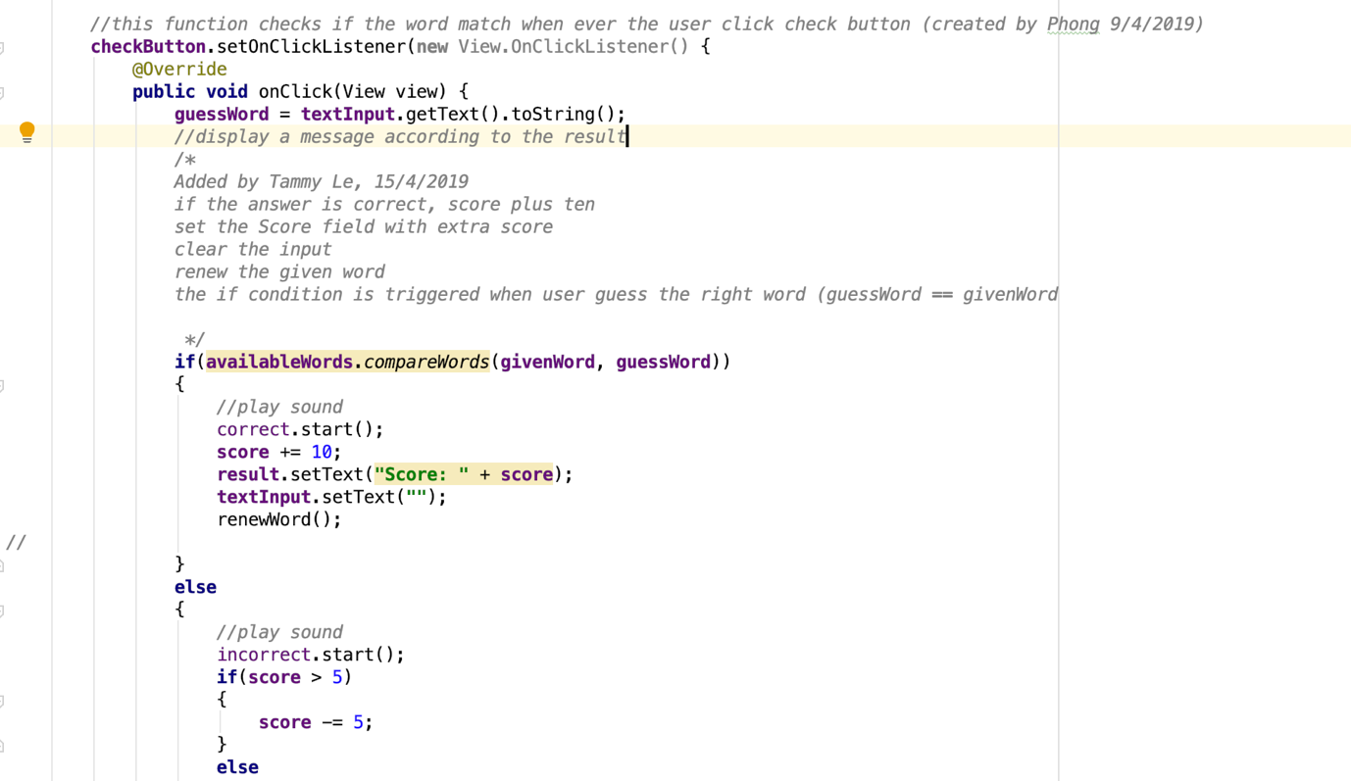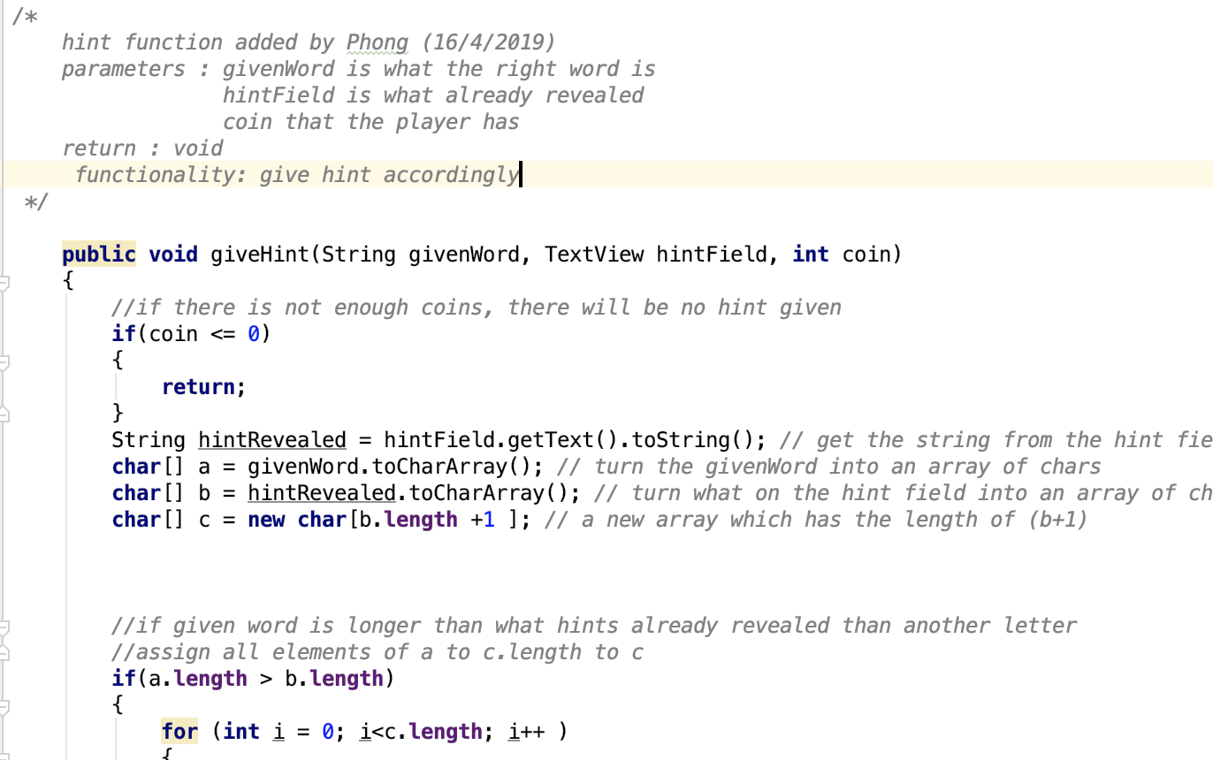

## Legal

LICENSE.txt has been added on the GitHub with all references of external sources used.

<<https://github.com/TAMMYLE/WordAddicts/blob/master/LICENSE.txt>>

## Value

Within speed mode, there are several levels that will challenge player to keep playing the game. At least 2 hours to reach level 4 which is the highest level of the app.

## Advanced Features

There are 3 advanced features that we have learnt

* Circular progress bar combining with timer
* Paypal payment
* CardView

## Data Handling

All data has been handled with SharePreferences.

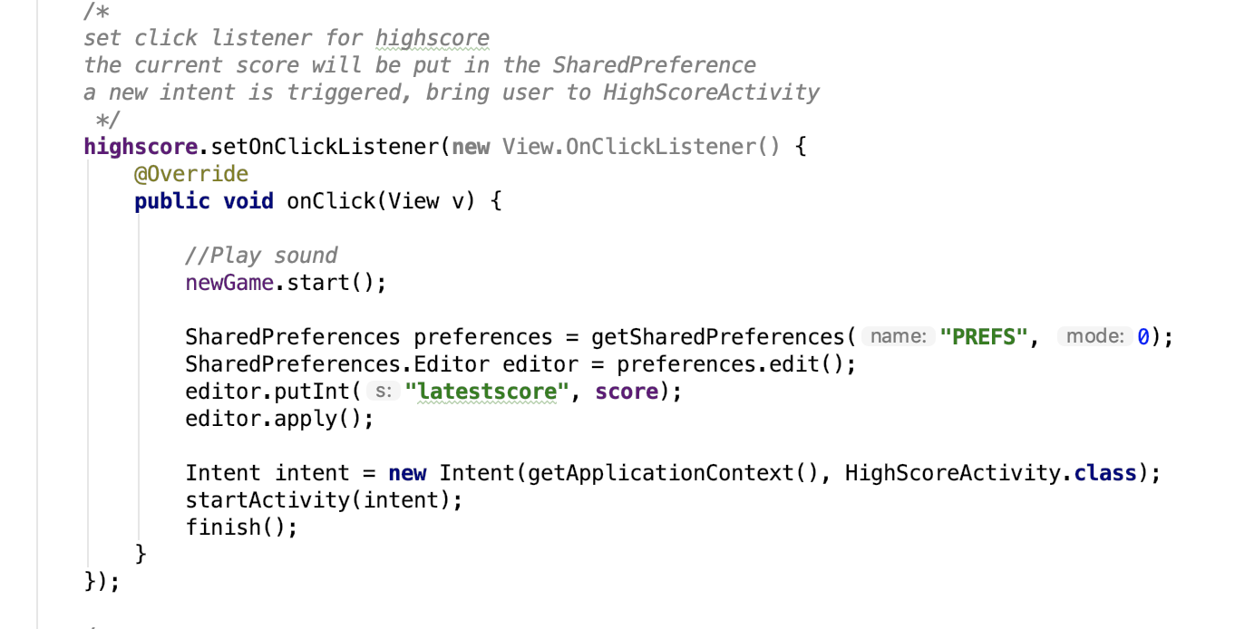

## Readme

Readme file will be linked to GitHub.

<https://github.com/TAMMYLE/WordAddicts/blob/master/README.md>